MARKING SCHEME
ARISE AND SHINE TRIAL II, TERM 2 EXAMINATIONS
231/2
BIOLOGY
Paper 2
Time: 2 Hours.
JULY 2026

SECTION A – (40 MARKS)
Answer All Questions In This Section InThe Spaces Provided.

1. Name the cell organelles that perform each of the following functions in a cell. (4 marks)
(a). (i). Synthesis of proteins – Ribosomes;
(ii). Transport cell secretions - Rough endoplasmic reticulum;
(iii). Destroy old and worn out organelles or even the entire cell –Lysosomes;
(iv). Package and transport glycoprotein – Golgi apparatus/Golgi bodies;
(b). Using a light microscope, a student counted 55 cell across a field of view whose diameter was 6000mm. Calculate the average length of the cells. Show your working. (3 marks)
Average length = $\frac{Diameter of the field of view}{Number of cells;}$
= $\frac{6000 μm}{55}$;=109;
(c).Why is it recommended to keep the stage of a microscope dry? (1 mark)
To avoid refraction of light; avoid wetting the slide;
2. The set up below shows a young plant that was inserted into pond water that contained all the ions needed for plant growth.

(a). Explain why:
(i). Air bubbles were blown into the solution. (2 marks)
To provide oxygen required for respiration; to provided energy for active uptake of the mineral salts/ions;
(ii). The apparatus was covered with a black paper. (2 marks)
To preset photosynthetic pond organisms from carrying out photosynthesis; utilizing the ions available in the solation;
(b). Briefly explain how the following would affect uptake of the ions by the plants:
(i). Low temperature (2 marks)
Inactivates respiratory enzymes; producing less energy for respiration; reducing uptake of ions by plants;
(ii). High glucose concentration in root hair cell sap. (2 marks)
Increases rate of respiration; producing more energy for active uptake of ions; leading to high rate of ion uptake;
3. (a). What is meant by the term linked genes? (1 mark)
Genes are located on the same chromosome and are always transmitted together;
(b). Haemophilia is a genetic condition transmitted through a recessive gene linked to
x- Chromosome. The normal gene may be represented by X^{H}.
(i) What is the genotype of haemophilic female? (1 mark)
X^{h}X^{h};

(ii). A woman who is a carrier for the haemophiliac gene marries a normal man. Work out the phenotypic ratio for their offspring. (4 marks)
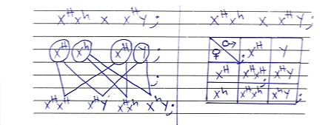

(iii). Haemophilia is more common in males than in females. Explain this phenomenon.
(2 marks)
Males lack corresponding allele on y chromosome; therefore thy cannot be carriers;
4. The diagram below shows part of a longitudinal section of a young root.

(a). Name the structure labeled G and H. (2 marks)
G- Cortex;
H – Endodermis;
(b). Give two ways in which the part labeled C is adapted to its function. (2 marks)
Elongated to increase surface area for absorption; This permeable wall for faster diffusion/osmosis of water and ions; large valued to lower water potential hence draw in water; may mitochondria for active transport of ions;
(c). Describe how water from the oil reaches structure J. (4 marks)
Cell sap of the root hair cells is hypertonic to the soil solution; water molecules more from the soil into the root hair cells by osmosis; the cell sap of the root hairs, because diluted hence becomes less concentrated then the adjacent cortex cells; water moves into the cortex cells by osmosis; water moves from cells to cells by osmosis until it reaches the endodermis; where it is actively pumped into the xylem vessel/J;
5. During a study,48 larvae were put in unpainted side of the petri dish as shown below.
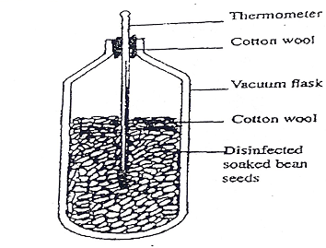
The Petri dish was left in bright sunshine, the number of larvae on unpainted side was counted every minute for five minutes and the results were as show below.
Time (min) | Number of larvae
Time (min) | In painted side | In unpainted side
0  1  2  3  4  5 | 0  38  41  45  47  48 | 48  10  7  3  1  0
(a).(i). What conclusion can you draw from these results about the behavior of the larvae?
(1 mark)
Larvae are negatively phototoxic;
(ii). Name the response exhibited by the larvae. (1 mark)
Negative photo taxis;

(iii). What is the survival value of this behaviour to the larvae? (2 marks)
Enable them to escape from predators; present desiccation; enable them select safe habitat for growth;
(b). A potted plant was placed horizontally with agar blocks as shown.

(i). Predict the growth curvature of the shoot. (1 mark)
Curves upward;
(ii). Account for your answer in (i) above (3 marks)
High concentration of auxins on lower side of the shoot promotes rapid growth leading to More elongation at the lower side; than upper side hence the shoot bends upwards;

SECTION B (40 MARKS)
Answer question 6 (compulsory) and either question 7 or 8 in this section.

(6). The following data was collected and recorded by environmental researchers during random field visit. It was noted that birds were feeding on both aphids and giant looper; the giant looper entirely feed on aphids. Study the data and use it to answer the questions that follow.

Organism | Population
Gallant soldier plant | 60
Giant looper | 100
Birds | 20
Aphids | 600
- Draw a pyramid of numbers to represent the data. (6 marks)
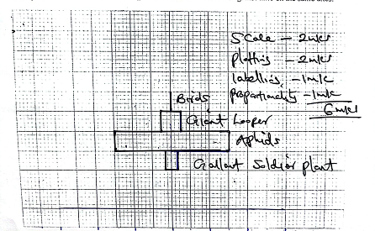

(b). Identify the type of pyramid above. (1 mark)
Inverted pyramid of numbers;
(c). (i). Discuss the shape of the pyramid drawn. (5 marks)
Pyramid is inverted; population of producers/plants is lower than the primary consumers; this is because the primary consumers are smaller in number (aphids); therefore a larger number of aphids can be sustained by only are plant; secondary consumers; a few of the secondary consumers can therefore be sustained by the primary consumer because some energy is lost;

(ii). Draw a food web to represent the data above. (2 marks)

Gallat soldier Aphids

Birds Giant looper
(d). Apart from the food web, name two other ways by which energy flow in the ecosystem is represented. (2 marks)
Pyramid of biomass; food chain; pyramid energy;
(e). A quadrat was used to estimate the population of a gallant soldier plants. Briefly describe how the method was used. (3 marks)
- Select suitable study area/identify the site;
- Estimate the area of the study;
- Throw guadrat randomly;
- count the number of gallant soldier
- Pelard;
- Get the average;
- Multiply average with the area of study;
(f). Apart from the quadrat method name another method of population estimation. (1 mark)
Belt transects; line transect;
7. Describe the various evidences that show that evolution has taken place. (20 marks)
……………………………………………………………………………………………………………………………………………………………………………………………………………………………………………………………………………………………………………………………………………………………………………………………………………………………….……………………………………………………………………………………………………………………………………………………………………………………………………………………………………………………………………………………………………………………………………………………………………………………………………………………………….
……………………………………………………………………………………………………………………………………………………………………………………………………………………………………………………………………………………………………………………………………………………………………………………………………………………………….
……………………………………………………………………………………………………………………………………………………………………………………………………………………………………………………………………………………………………………………………………………………………………………………………………………………………….
……………………………………………………………………………………………………………………………………………………………………………………………………………………………………………………………………………………………………………………………………………………………………………………………………………………………….
……………………………………………………………………………………………………………………………………………………………………………………………………………………………………………………………………………………………………………………………………………………………………………………………………………………………….
……………………………………………………………………………………………………………………………………………………………………………………………………………………………………………………………………………………………………………………………………………………………………………………………………………………………….
……………………………………………………………………………………………………………………………………………………………………………………………………………………………………………………………………………………………………………………………………………………………………………………………………………………………….
……………………………………………………………………………………………………………………………………………………………………………………………………………………………………………………………………………………………………………………………………………………………………………………………………………………………….
……………………………………………………………………………………………………………………………………………………………………………………………………………………………………………………………………………………………………………………………………………………………………………………………………………………………….
……………………………………………………………………………………………………………………………………………………………………………………………………………………………………………………………………………………………………………………………………………………………………………………………………………………………….
………………………………………………………………………………………………………………………………………………………………………………………………………………

8. Describe adaptation of fruits and seeds to various methods of dispersal. (20 marks)
Animal dispersal
Some fruits have hooks; that stick on the fur/hairs/clothes of animals, and are carried away from the parent plant
Some fruits are succulent/fleshy/juicy; y animals; and their seeds are thrown away from the parent plant;
Some fruits have brightly colored pericials
Some fruits are scented; to attract animal,
Some fruits have seeds with seed coats the resistant to digestive enzymes; The seeds are swallowed and passed out in feaces without being digested;

Wind Dispersal
Some fruits and seeds have hairy/feather-like projections; to increase the surface area enabling them to be carried by wind;
Some fruits and seeds have wing like structures, to increase the surface area to be easily carried by wind;
Seeds are small and light; enabling them to be carried by wind;
Some fruits have censor mechanism; the fruit is capsule shaped, attached to a long stalk, which wered by wind, the seeds are shaken and scattered;

Water dispersal
The seed coat is waterproof; to prevent soaking water and sinking;
Some fruits have fibrous mesocarp filled with air making them light hence float on water,
Dispersal
The fruits have limes of weakness/sutures; that open violently throwing the seeds away from parent plant; total 26 marks maxx14 marks

